**LAB : 7**

**TOPIC :** Activity Diagram

**Requrements :**

(a) Windows PC (Windows 7/8/10) / Mac

(b) Star UML Tool

**Activity Diagram :**

1. Consider the process of ordering a pizza over the phone. Draw an activity diagram representing each step of the process, from the moment you pick up the phone to the point where you start eating the pizza. Do not represent any exceptions. Include activities that others need to perform.

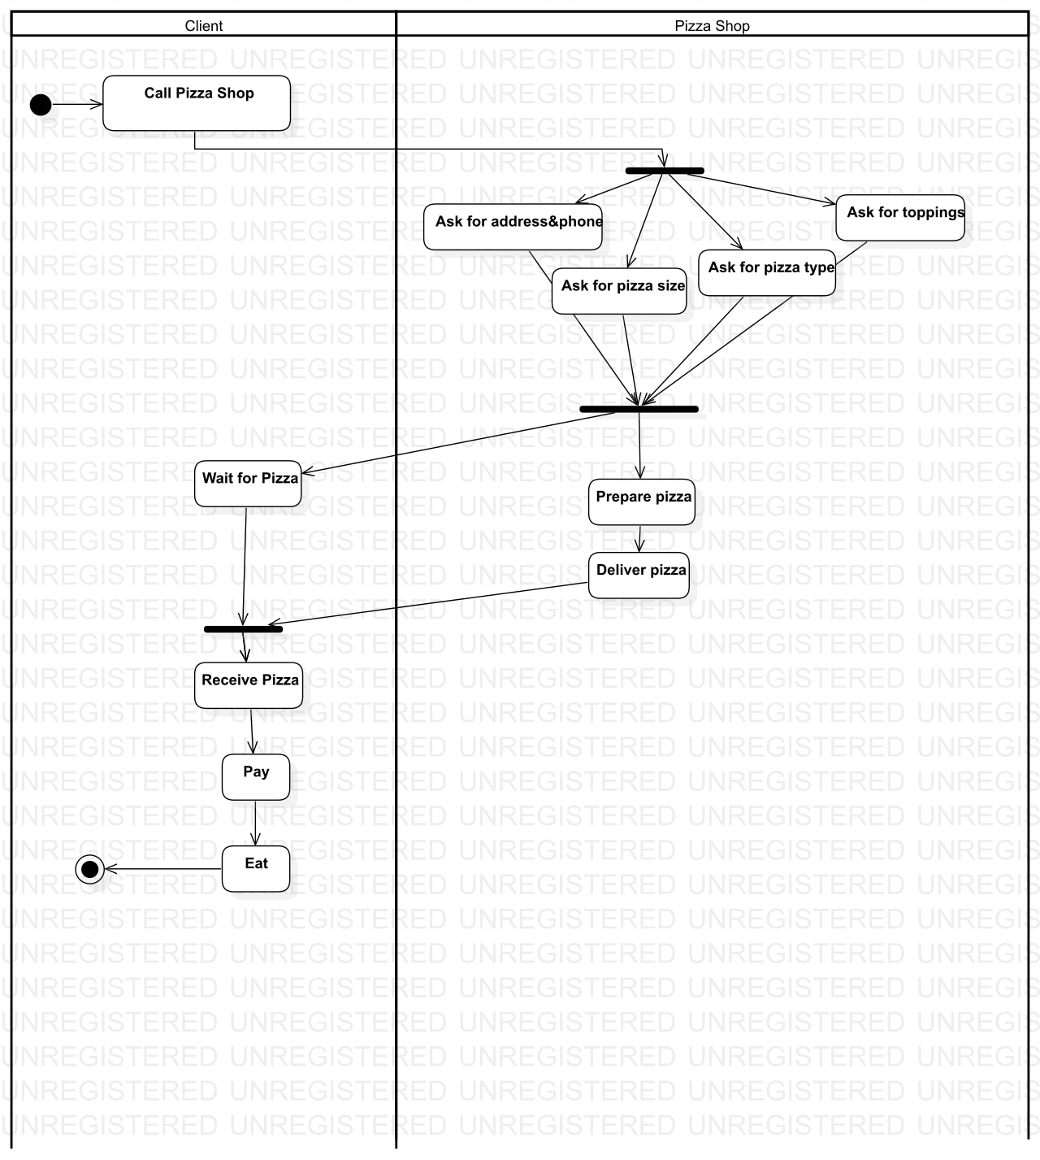

1. Add exception handling to the activity diagram you developed in Exercise 7-1. Consider at least three exceptions (e.g., delivery person wrote down wrong address, deliver person brings wrong pizza, store out of anchovies).

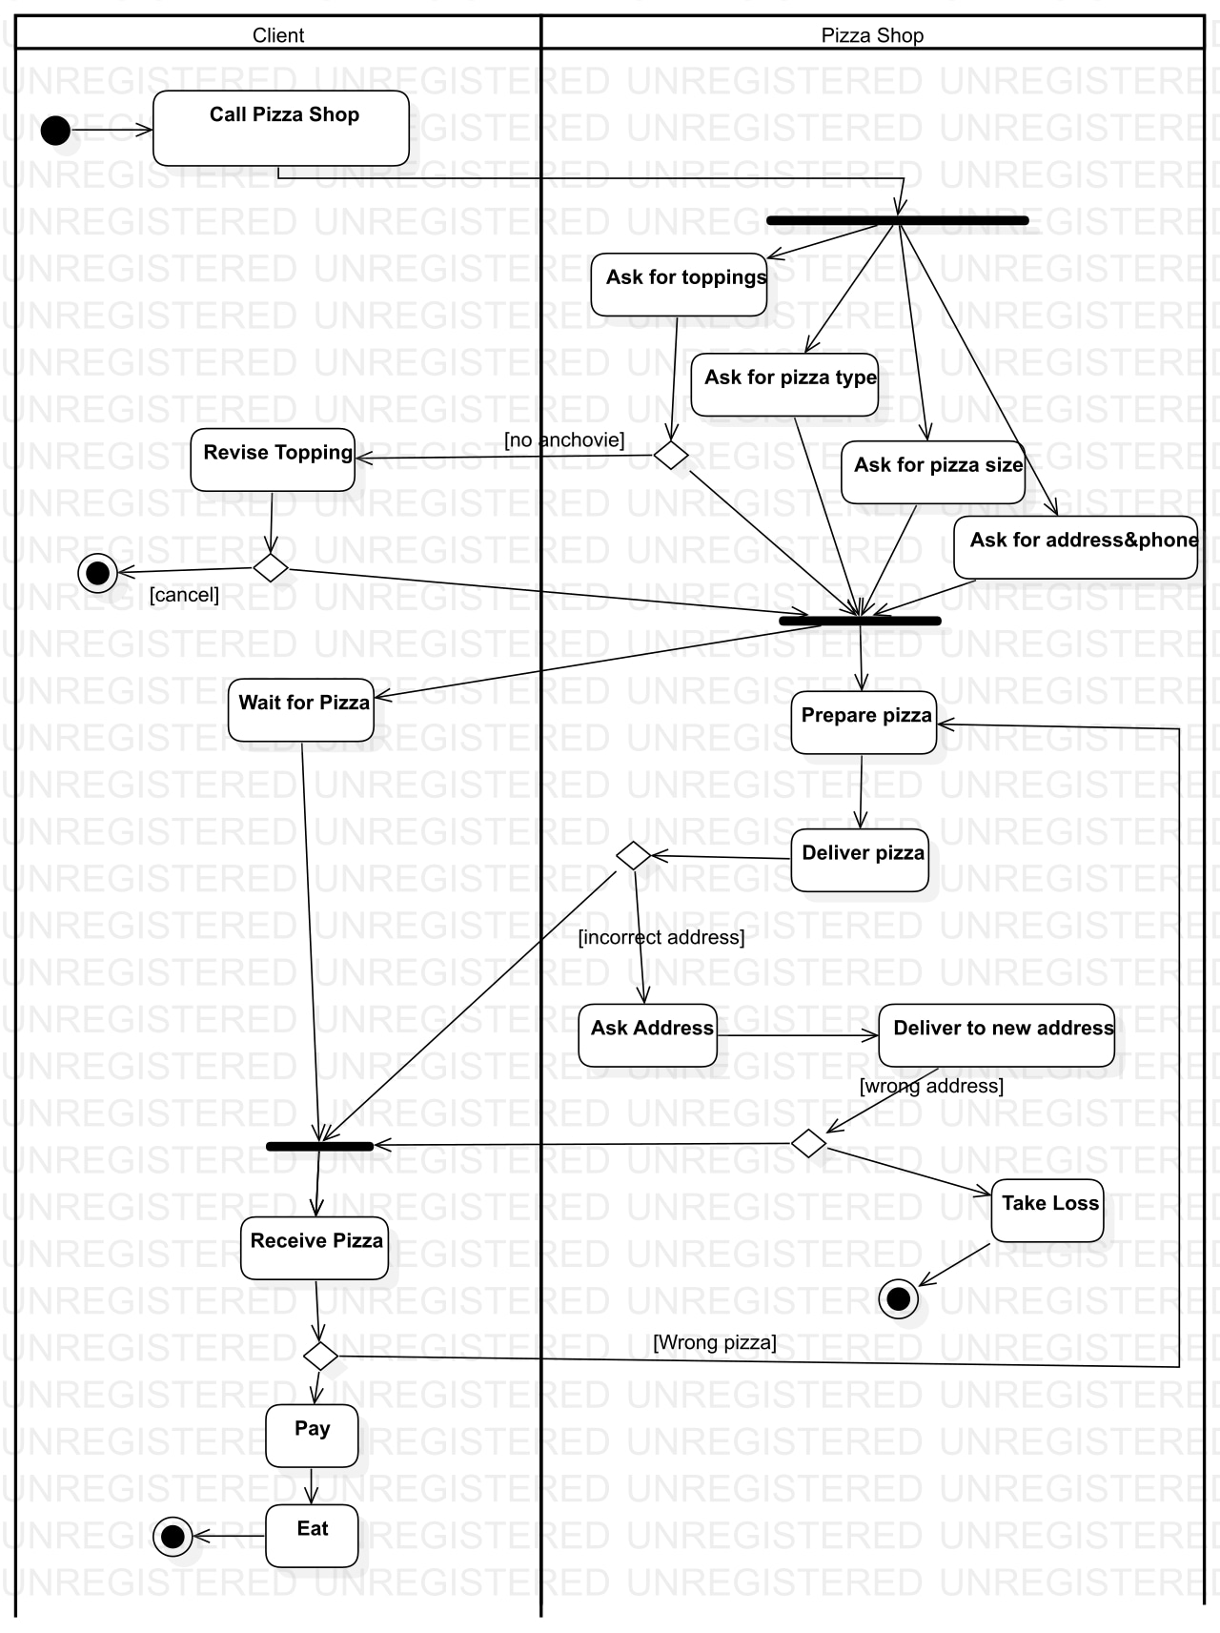

1. Consider the software development activities which we described in 7-1. Draw an activity diagram depicting these activities, assuming they are executed strictly sequentially. Draw a second activity diagram depicting the same activities occurring incrementally (i.e., one part of the system is analyzed, designed, implemented, and tested completely before the next part of the system is developed). Draw a third activity diagram depicting the same activities occurring concurrently.

